**EMPLOYEE PAYSLIP**

**FORM DESIGN**

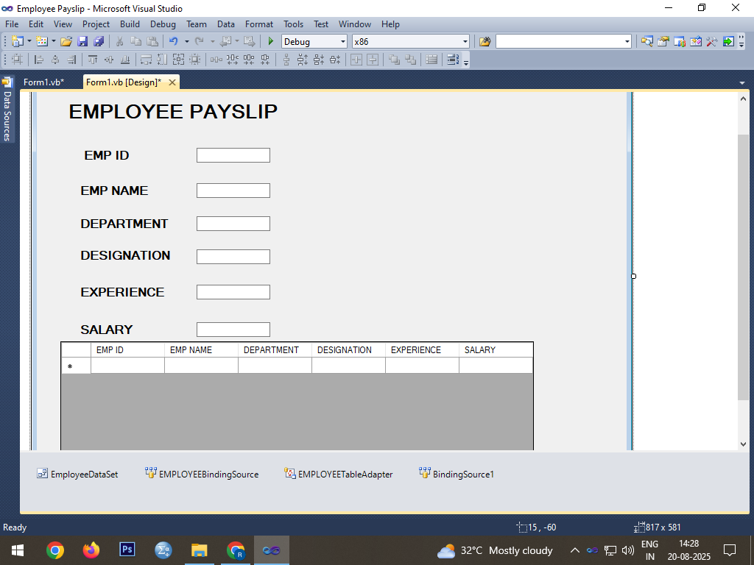

**CODING**

Public Class Form1

Private Sub Form1_Load(ByVal sender As System.Object, ByVal e As System.EventArgs) Handles MyBase.Load

'TODO: This line of code loads data into the 'EmployeeDataSet.EMPLOYEE' table. You can move, or remove it, as needed.

Me.EMPLOYEETableAdapter.Fill(Me.EmployeeDataSet.EMPLOYEE)

End Sub

End Class

**OUTPUT**

